






Create, implement and evaluate strategic product initiatives
D2.TCS.CL5.07
Trainee Manual

Create, implement and evaluate strategic product initiatives
D2.TCS.CL5.07
Trainee Manual





Project Base
William Angliss Institute of TAFE
555 La Trobe Street
Melbourne 3000 Victoria
Telephone: | (03) 9606 2111
Facsimile: | (03) 9670 1330
Acknowledgements
Project Director: | Wayne Crosbie
Project Manager | Jim Irwin
Chief Writer: | Alan Hickman
Subject Writer: | Quentin Derrick
Editor: | Jim Irwin
DTP/Production: | Daniel Chee, Mai Vu, Cindy Curran

The Association of Southeast Asian Nations (ASEAN) was established on 8 August 1967. The Member States of the Association are Brunei Darussalam, Cambodia, Indonesia, Lao PDR, Malaysia, Myanmar, Philippines, Singapore, Thailand and Viet Nam.
The ASEAN Secretariat is based in Jakarta, Indonesia.
General Information on ASEAN appears online at the ASEAN Website: www.asean.org.
All text is produced by William Angliss Institute of TAFE for the ASEAN Project on “Toolbox Development for Tourism Labour Divisions for Travel Agencies and Tour Operations”.
This publication is supported by the Australian Government’s aid program through the ASEAN-Australia Development Cooperation Program Phase II (AADCP II).
Copyright: Association of Southeast Asian Nations (ASEAN) 2015.
All rights reserved.
Disclaimer
Every effort has been made to ensure that this publication is free from errors or omissions. However, you should conduct your own enquiries and seek professional advice before relying on any fact, statement or matter contained in this book. The ASEAN Secretariat and William Angliss Institute of TAFE are not responsible for any injury, loss or damage as a result of material included or omitted from this course. Information in this module is current at the time of publication. Time of publication is indicated in the date stamp at the bottom of each page.
Some images appearing in this resource have been purchased from stock photography suppliers Shutterstock and iStockphoto and other third party copyright owners and as such are non-transferable and non-exclusive. Clip arts, font images and illustrations used are from the Microsoft Office Clip Art and Media Library. Some images have been provided by and are the property of William Angliss Institute.
Additional images have been sourced from Flickr and SXC and are used under Creative Commons licence: http://creativecommons.org/licenses/by/2.0/deed.en

File name: TM_Create_implement__evaluate_strategic_prod_270415





Table of contents
Introduction to trainee manual 1
Unit descriptor 3
Assessment matrix 5
Glossary 7
Element 1: Create strategic product initiatives 9
Element 2: Implement strategic product initiatives 27
Element 3: Evaluate strategic product initiatives 41
Presentation of written work 47
Recommended reading 49
Trainee evaluation sheet 51
Trainee self-assessment checklist 53

Introduction to trainee manual

To the Trainee
Congratulations on joining this course. This Trainee Manual is one part of a ‘toolbox’ which is a resource provided to trainees, trainers and assessors to help you become competent in various areas of your work.
The ‘toolbox’ consists of three elements:
- A Trainee Manual for you to read and study at home or in class
- A Trainer Guide with Power Point slides to help your Trainer explain the content of the training material and provide class activities to help with practice
- An Assessment Manual which provides your Assessor with oral and written questions and other assessment tasks to establish whether or not you have achieved competency.
The first thing you may notice is that this training program and the information you find in the Trainee Manual seems different to the textbooks you have used previously. This is because the method of instruction and examination is different. The method used is called Competency based training (CBT) and Competency based assessment (CBA). CBT and CBA is the training and assessment system chosen by ASEAN (Association of South-East Asian Nations) to train people to work in the tourism and hospitality industry throughout all the ASEAN member states.
What is the CBT and CBA system and why has it been adopted by ASEAN?
CBT is a way of training that concentrates on what a worker can do or is required to do at work. The aim is of the training is to enable trainees to perform tasks and duties at a standard expected by employers. CBT seeks to develop the skills, knowledge and attitudes (or recognise the ones the trainee already possesses) to achieve the required competency standard. ASEAN has adopted the CBT/CBA training system as it is able to produce the type of worker that industry is looking for and this therefore increases trainees chances of obtaining employment.
CBA involves collecting evidence and making a judgement of the extent to which a worker can perform his/her duties at the required competency standard. Where a trainee can already demonstrate a degree of competency, either due to prior training or work experience, a process of ‘Recognition of Prior Learning’ (RPL) is available to trainees to recognise this. Please speak to your trainer about RPL if you think this applies to you.
What is a competency standard?
Competency standards are descriptions of the skills and knowledge required to perform a task or activity at the level of a required standard.
242 competency standards for the tourism and hospitality industries throughout the ASEAN region have been developed to cover all the knowledge, skills and attitudes required to work in the following occupational areas:
- Housekeeping
- Food Production
- Food and Beverage Service
- Front Office
- Travel Agencies
- Tour Operations.
All of these competency standards are available for you to look at. In fact you will find a summary of each one at the beginning of each Trainee Manual under the heading ‘Unit Descriptor’. The unit descriptor describes the content of the unit you will be studying in the Trainee Manual and provides a table of contents which are divided up into ‘Elements’ and ‘Performance Criteria”. An element is a description of one aspect of what has to be achieved in the workplace. The ‘Performance Criteria’ below each element details the level of performance that needs to be demonstrated to be declared competent.
There are other components of the competency standard:
- Unit Title: statement about what is to be done in the workplace
- Unit Number: unique number identifying the particular competency
- Nominal hours: number of classroom or practical hours usually needed to complete the competency. We call them ‘nominal’ hours because they can vary e.g. sometimes it will take an individual less time to complete a unit of competency because he/she has prior knowledge or work experience in that area.
The final heading you will see before you start reading the Trainee Manual is the ‘Assessment Matrix’. Competency based assessment requires trainees to be assessed in at least 2 – 3 different ways, one of which must be practical. This section outlines three ways assessment can be carried out and includes work projects, written questions and oral questions. The matrix is designed to show you which performance criteria will be assessed and how they will be assessed. Your trainer and/or assessor may also use other assessment methods including ‘Observation Checklist’ and ‘Third Party Statement’. An observation checklist is a way of recording how you perform at work and a third party statement is a statement by a supervisor or employer about the degree of competence they believe you have achieved. This can be based on observing your workplace performance, inspecting your work or gaining feedback from fellow workers.
Your trainer and/or assessor may use other methods to assess you such as:
- Journals
- Oral presentations
- Role plays
- Log books
- Group projects
- Practical demonstrations.
Remember your trainer is there to help you succeed and become competent. Please feel free to ask him or her for more explanation of what you have just read and of what is expected from you and best wishes for your future studies and future career in tourism and hospitality.

Unit descriptor
Create, implement and evaluate strategic product initiatives
This unit deals with the skills and knowledge required to Create, implement and evaluate strategic product initiatives in a range of settings within the travel industries workplace context.
Unit Code:
D2.TCS.CL5.07
Nominal Hours:
70

Element 1: Create strategic product initiatives
Performance Criteria
1.1 Identify the context for product development
1.2 Undertake market research on identified opportunities and identified target markets
1.3 Determine product life cycle issues that apply to identified opportunities and products
1.4 Determine financial issues that relate to the development of product initiatives
1.5 Research product development opportunities that align with the context that applies
1.6 Develop product development plans reflecting research information and business objectives
1.7 Produce the identified product or service initiative

Element 2: Implement strategic product initiatives
Performance Criteria
2.1 Trial the initiative in accordance with established plans
2.2 Revise the initiative as required on the basis of operational matters and customer feedback
2.3 Monitor the introduction and implementation of the initiative
2.4 Apply change management skills to facilitate the introduction and establishment of the initiative
2.5 Promote the initiative to customers

Element 3: Evaluate strategic product initiatives
Performance Criteria
3.1 Record statistical data to enable evaluation against Key Performance Indicators to occur
3.2 Solicit and record feedback from stakeholders
3.3 Compare projected outcomes against actual outcomes
3.4 Determine and implement changes, if any, that need to be made to maintain or revise the initiative

Assessment matrix
Showing mapping of Performance Criteria against Work Projects, Written Questions and Oral Questions
The Assessment Matrix indicates three of the most common assessment activities your Assessor may use to assess your understanding of the content of this manual and your performance - Work Projects, Written Questions and Oral Questions. It also indicates where you can find the subject content related to these assessment activities in the Trainee Manual (i.e. under which element or performance criteria). As explained in the Introduction, however, the assessors are free to choose which assessment activities are most suitable to best capture evidence of competency as they deem appropriate for individual students.
 |  |  | Work Projects | Written Questions | Oral Questions
Element 1: Create strategic product initiatives
1.1 | Identify the context for product development |  | 1.1 | 1 | 1
1.2 | Undertake market research on identified opportunities and identified target markets |  | 1.2 | 2 | 2
1.3 | Determine product life cycle issues that apply to identified opportunities and products |  | 1.3 | 3 | 3
1.4 | Determine financial issues that relate to the development of product initiatives |  | 1.4 | 4 | 4
1.5 | Research product development opportunities that align with the context that applies |  | 1.5 | 5 | 5
1.6 | Develop product development plans reflecting research information and business objectives |  | 1.6 | 6 | 6
1.7 | Produce the identified product or service initiative |  | 1.7 | 7 | 7
Element 2: Implement strategic product initiatives
2.1 |  | Trial the initiative in accordance with established plans | 2.1 | 8 | 8
2.2 |  | Revise the initiative as required on the basis of operational matters and customer feedback | 2.2 | 9 | 9
2.3 |  | Monitor the introduction and implementation of the initiative | 2.3 | 10 | 10
2.4 |  | Apply change management skills to facilitate the introduction and establishment of the initiative | 2.4 | 11 | 11
2.5 |  | Promote the initiative to customers | 2.5 | 12 | 12
Element 3: Evaluate strategic product initiatives
3.1 | Record statistical data to enable evaluation against Key Performance Indicators to occur |  | 3.1 | 13 | 13
3.2 | Solicit and record feedback from stakeholders |  | 3.2 | 14 | 14
3.3 | Compare projected outcomes against actual outcomes |  | 3.3 | 15 | 15
3.4 | Determine and implement changes, if any, that need to be made to maintain or revise the initiative |  | 3.4 | 16 | 16

Glossary
Term | Explanation
Analyse | to examine
Consumer | a person who buys something and uses it
Customer | a person who buys something
Evaluate | analyse
Feedback | information provided by a customer about a product or service
Initiative | an activity or idea that is new
Loss | a negative monetary gain, deficit
Monitor | check or watch
Opportunity | a potential new business lead
Product | something that is developed to be sold
Product life cycle | the stages that a product goes through from introduction to demise
Research | systematic investigation
Revise | reconsider and alter or change
Service | the action of helping or doing work for someone
Statistic | a fact or piece of data
Strategy | a plan of action

Element 1:
Create strategic product initiatives

1.1 Identify the context for product development

Introduction
The business context in which an organisation operates can involve many varying aspects. When trying to identify product initiatives it is important to understand the context surrounding and influencing the need for product development. The first step in developing new products or updating existing products or services is to identify what customers want and need.


Marketing Mix
The marketing mix is one of the fundamental starting points for identifying the context in which new products and services exist. The marketing mix includes four parts, often referred to as the four P’s: price, product, place and promotion. These four marketing variables operate within an external environment which includes competitive, political and legal, technological, social, and economic factors. All of these components influence the type of products and services that your organisation will develop.

Competitive

Social
Technological
Political& Legal
Economic

The Four P’s

Price
The price aspect of the marketing mix refers to the value of an organisation’s products and service. Some of the factors that influence price may be the cost to make or deliver the product or service, discounting strategies, and positioning in relation to competitor pricing.

Product
These are the goods and services that an organisation offers to its customers or consumers. Products and services have both tangible and intangible aspects and services are often intangible in that you can’t see, touch or feel the service, only the effect of it or impression.

Place
This refers to how and where the product or services are being delivered to customers. The place where product or service delivery occurs has a significant impact on deciding to develop or deliver a service. Place is sometimes referred to as distribution and includes location, facilities, and whether other intermediary partners are needed.

Promotion
Promotion relates to how customers are informed about the product or service and includes advertising, sales promotion, public relations and personal sales.

External Environment

Competition
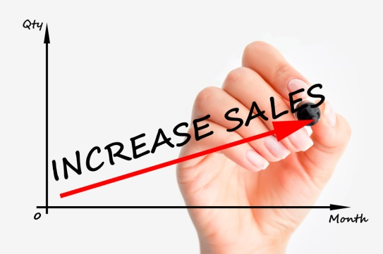
In identifying the context in which the product and services are being developed, it is important to understand the current market in which an organisation is operating. Part of this process includes identifying what products and services competitors are offering and deciding whether there is an opportunity to compete with other organisations. This may involve your organisation investigating the products and services it offers, and comparing them with similar products and services offered by competitors. The Four P’s could form a base for investigation and comparison in order to determine ways in which your organisation can improve existing products and services, or develop new ones.

Economic
The economic environment in which an organisation is operating will impact directly on the products and services that the organisation will develop and deliver. A strong and healthy local or national economy might assist in the development of new or existing products and services as consumers and customers will have more money to spend on hospitality and tourism activities. The Global Economic Crisis (GEC) directly impacted hospitality and tourism markets all over the world so it is important to assess the current economic situation before making decisions about product and service development and implementation.

Social
The social environment is related to all other external environments as changes in the economy, technology, competitive arena, and government and legal adjustments all affect consumer attitude and behaviour. Demographical shifts in terms of population growth, gender, marital status, age, income, occupation and education all influence the social environment and can shape consumer opinions, attitudes and interests.

Technological
Technology changes at a rapid pace and new software, applications, and equipment become available almost daily. Introducing new technology to support new products and services requires a clearly outlined process for implementation and cost, training, access and staff skills need to be considered before purchasing new technology. It is important to think carefully about the benefits that technological change will bring to the organisation compared with the challenges that implementing new technology can also bring.

Political and Legal
The laws and regulations set by government directly impact on business operations. Changes in government at local, state, national and international level can all have an impact on business practices and it is important to monitor and be aware of legal and political changes when considering developing new products and services. Occupational health and safety law changes, tax changes, and staff qualification regulations all affect the products and services that an organisation sells and delivers.



SWOT Analysis
Any situational analysis will begin with a Strengths, Weaknesses, Opportunities and Threats (SWOT) analysis. This process allows an organisation to identify areas for improvement and products and services that are performing well. It also provides an insight into potential areas of risk. Below is an example of what information could be considered when undertaking a SWOT analysis. It is important that the process is conducted without emotion and prejudice and looks at the facts to determine each categories performance.
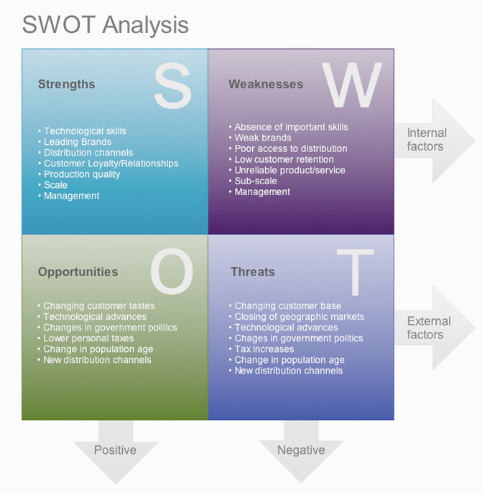

BCG Matrix
Another matrix that is used to determine what products and services are successful or not is the Boston Consulting Group Matrix. This is similar to a SWOT analysis but identifies business performance areas to improve, cease or develop. Stars are the products, services or business lines that are performing well and they should be promoted and encouraged to grow. Cash cows are the services and products that consistently produce good results and are often the core business. The revenue that they produce is used to fund Stars and potential question marks. Question marks are the products and services that an organisation is not sure about. It is important to analyse why these business lines are not performing as well as expected and a decision needs to be made whether to continue or cease these products and services. Dogs are under-performing products and services and they should be stopped.
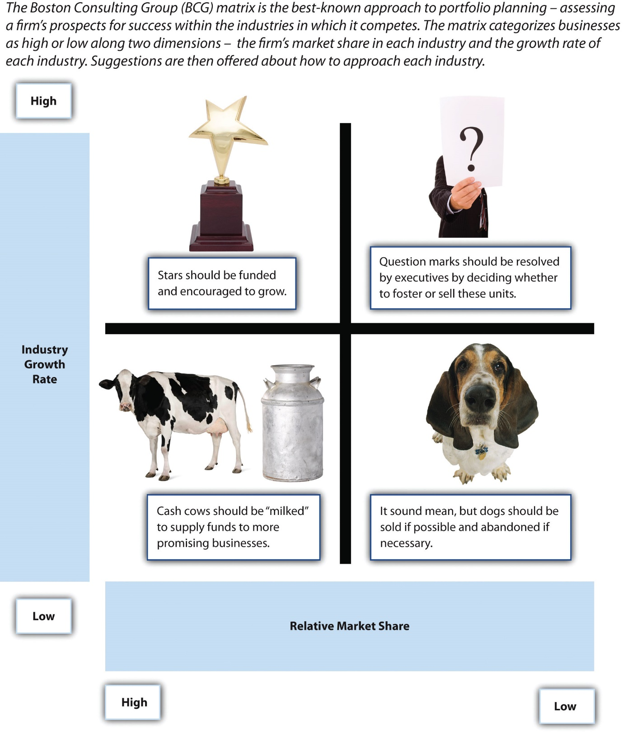
It sounds mean, but dogs should be sold if possible and abandoned if necessary.
Question marks should be resolved by executives by deciding whether to foster or sell these units.
Stars should be funded and encouraged to grow.
Cash cows should be “milked” to supply funds to more promising business.

1.2 Undertake market research on identified opportunities and identified target markets

Introduction

There is a lot of information that can be accessed and analysed in order to make informed decisions about whether there is a need and opportunity for developing a new product or service. Conducting market research is a critical stage in new product and service development and forms the bases for deciding which products and services have been successful and what new services and products are needed.

Objectives for market research
Before undertaking market research activities, it is important to first determine the desired outcomes or objectives of the research. Identifying the objectives provides a clearer picture of what data or information will be required in order to make informed decisions about new product opportunities and initiatives. Market research objectives need to align with the organisation’s goals and mission as well. It is necessary, therefore, to identify enterprise mission and business strategy in order to ensure that the market research activities fit within the company’s goals as a whole. Objectives should also follow the SMART rule in that they should be:
- Specific, Measurable, Achievable, Realistic, Time-based.
In developing market research objectives it may be helpful to ask:
- What is the organisation’s overall strategy?
- How does the organisation work to achieve these goals?
- What resources are available or needed to undertake the market research?
- Are the objectives achievable and realistic?
- What are the timeframes for market research activities?
- What finances or budget are required?



Collecting Data
The first decision that is required when conducting market research is to determine what information is necessary and available. Data can be classified as primary and secondary where primary data is collected for a specific designated reason and secondary data is previously gathered information that may be relevant and useful for another purpose. Developing primary data research and collecting information can be extremely costly and time consuming so any market research activity should begin with an investigation of secondary data. Primary data collection methods could include targeted focus groups, questionnaires, interviews, meetings, surveys, observation and case studies.
Secondary data could be sourced from financial information and reports, human resource documents, staff and customer feedback, industry associations, industry journals and publications, government and university studies and reports, and sales data. Secondary data can be gathered internally from within the organisation and externally through various sources. If the secondary data is not adequate or appropriate primary market research activities may be needed.
One area that might need to be analysed is that of product or service performance. Using secondary data it is possible to investigate sales, costs, profit and customers/consumers. Some questions that could lead market research in these areas are:
- Have sales gone up or down?

- What could have affected sales results?
- Which market segments or products have performed well? Why/Why not?
- What are the relative costs of a product or service?
- Are these acceptable/increasing/decreasing? Why?
- What other factors impact on the cost of product or service delivery?
- Is the service or product profitable?
- Do customers need or want the service or product? How do we know?
- Are customers happy or satisfied with an existing service or product?

Data collection techniques could draw upon quantitative or qualitative data. Quantities data is numerical, statistically reliable and applicable to a broader context. Qualitative data is non-numerical, in-depth and directional in that it can show where to go with product or service development. Once the research methods have been chosen, the data must be gathered. Secondary sources of data should be collected first and then a decision needs to be made as to whether primary data is also needed.
After gathering and collating all of the available market research data, an analysis and examination of the information needs to be conducted. The results need to be examined and checked against outlined market research objectives. Based upon the analysis, specific products and services could be identified as potential opportunities or it may be necessary to alter or cease product or service development and delivery.

1.3 Determine product life cycle issues that apply to identified opportunities and products

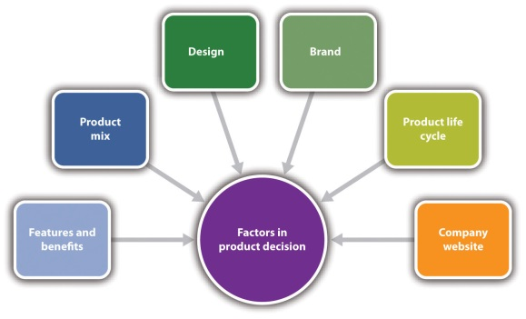
Introduction
The product life cycle theory outlines how a product or a service moves from its original beginning as an idea, through development and implementation, to potential decline. The stage at which a product or service is at within the product life cycle can impact on what strategies are required to positively influence the product or service which could lead to reinvesting in the product or even ceasing delivery or offering of it.

Product life cycle
The product life cycle includes several stages that can be analysed to determine what action should be applied to a product or service in order to enhance it or extend its life. The four stages include introduction, growth, maturity and decline.
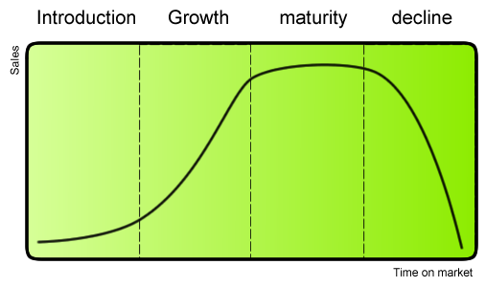

Introduction
At the introduction stage, a product or service has been through planning and development processes and is now ready to be launched. The product or service has been tested, analysed and market research has been conducted. As can be seen in the graph above, the initial introduction phase may not result in significant sales as the product or service needs to become known by the market.

Growth
At this stage, the customer base grows and more people become aware of the product or service. Sales increase significantly and profit should increase as well. Some small adjustments may need to be implemented at this stage, but the customer uptake of the product or service will continue to increase at the growth stage. The amount of growth and the duration of growth is not fixed and it may continue for a long time or it may be quick and steep but then plateau.

Maturity
After the growth stage, a product or service may cease to grow and sales may just level off. At this point in the market life cycle, the customer base may have reached its highest level and there is no room for increased market penetration if the product or service remains the same. Often competition has increased at this stage and the market has become saturated with providers or organisations offering the same or similar products and services. At the maturity stage, an organisation may look at ways to show customers how their product or service is unique from competitors, in an attempt to persuade customers to switch from a competitor to its product. There may also be a need to keep current customers so marketing campaigns may be developed to maintain the existing market share. Many products and services stay at the maturity stage and may not transition to the next stage.

Decline
In the final stage of the cycle, a product or service’s sales and profits begin to decline. There may be many competitors in the market at this point and discounting has become more prevalent. At this point, an organisation may need to lower costs in delivery by reducing customer service levels, staffing, effort and marketing or promotion and the existing loyal customers may be all the organisation is focused on maintaining. Some competitors may cease delivery or offering of a service or product at this stage so there may be opportunities to attract customers from competitors.

The product life cycle as a tool

In order to take advantage of the product life cycle, it is necessary to identify where a product or service is at within the cycle and to examine competitor products and services within the four stages. It is possible to extend the product life cycle by increasing sales to current customers through encouraging them to buy more or to purchase more often.
It is possible to apply market penetration strategies to increase the amount of customers by attracting new customers to purchase the product or service. This may be difficult if there is growing competition and investment may be needed, but there may still be an opportunity to increase market share. For example, a hotel or resort may realise that there are local customers interested in using the facilities and the organisation may offer a special rate for local residents to use the gym, pool and offer discounts for food and beverage purchases.
Finding new uses for the existing product or service is also a potential opportunity to increase sales and extend the product life cycle. Different uses for a product or service may be discovered and promoted by the enterprise or it may be as a result of customer feedback.

1.4 Determine financial issues that relate to the development of product initiatives

Introduction

There are many aspects that need to be considered when developing and introducing new products and services. One of the most important factors to consider is financial issues that may affect product or service development. It may be determined that there is an opportunity to develop a new product or service but if the required funding is not available introducing the new item may not be viable. It is critical to examine all of the financial issues that may impact on new product or service initiatives.

Financial issues to consider

An integral part of any new product or service initiative is to examine the costs and potential profits associated with the development and introduction of the idea. Some questions relating to finances that need to be considered include:
- How much will the product or service cost to develop and implement?
- What funds are available within the organisation or externally to support the product initiative?
- What is the organisation’s current cash flow situation and is there enough cash available to support the initiative?
- Are there additional funding opportunities from partners, stakeholders, government bodies, grants or financial incentives available?
- Is there any tax or increased cost affects relating to the product or service development?

1.5 Develop product development plans reflecting research information and business objectives


Introduction
All companies need to investigate product and service development opportunities in order to grow business, utilise the organisation’s resources effectively, and to increase market share. Relying on only one or two products or services opens an organisation to a lot of risk as new competitors could dilute the market which could lead to significant revenue decreases. It is important for enterprises to identify new product and service opportunities within the operational context.

Researching opportunities
Identifying business opportunities can be a challenging activity and it is important to utilise all available information and data before beginning a product development plan. Opportunities may be determined by a change in the external environment where an organisation sees a gap in the market place or a need that isn’t being met. Opportunities could also be identified by existing customers or by staff but it is necessary to determine what benefits new products may bring and whether they are feasible within the organisation’s context. The SWOT analysis will often provide a general idea of opportunities that could be targeted and further investigation is needed to decide if there is an opportunity to develop a new product or service.
After identifying potential business development opportunities, it is important to gather information and input from relevant sources. These sources could include:
- Visits or experience of competitor products and services

- Encouraging input from relevant stakeholders including staff, colleagues, local communities, existing customers, authorities, industry professionals and suppliers
- Investigation and analysis of cost-benefits and increased revenue opportunities related to product development and introduction
- Identification of gaps that may exist within the organisation and determining what resources are needed to successfully implement a new product or service
- Conducting market research activities to identify potential customer response to new product or service development

1.6 Develop product development plans reflecting research information and business objectives

Introduction

There are several stages required to successfully introduce a new product or service within an organisation. The process starts with an idea and progresses towards the introduction of the product or service into operations. There are a lot of risks associated with the introduction of new products and it is critical to plan effectively and make sure that new product initiatives respond to a market need and reflect the overall goals and mission of the organisation.

Product development plan
The first step in the product process is to generate a product or service development idea and as seen in the previous unit it is important to examine data and information that relates to potential product development opportunities. After identifying potential product or service initiatives, it is necessary to examine or screen these ideas to determine which ones are the most viable and beneficial. It may be useful to develop a set of criteria to assess new product ideas which could include:
- Most prominently identified customer needs
- Product improvements most needed
- The benefits to your target market
- The technical feasibility of the idea
- The level and scope of research and development required
- The profitability of the idea. What is its potential appeal to the market? How would you price it? What are the costs in bringing it to market – overall and per unit?
- Where the product fits in the market. Is there a gap? How close is it to competitor products?
- The resources it will require in development
- The marketing potential of the idea
- The fit with your business profile and business objectives.
(Queensland Government Business ©The State of Queensland 1995-2015)
After screening the product or service the next step is to create and test the product or service concept. A product or service concept includes a detailed description of the product and provides a clear outline of the product or service. It may be beneficial to develop the concept from a customer’s perspective in order to ensure that the product is aligned with customer needs. Concept testing involves customers and stakeholders being shown the concept and the organisation gathering feedback from them. A focus group may be used at this stage in the development plan process.

The next stage in the product development plan is to analyse the business potential of the new product or service. Consumer responses from the concept testing phase are analysed to determine the potential sales and market share which enables financial projections of costs and potential revenue to be examined. It may be necessary to conduct a break-even analysis at this stage and to look at several scenarios that range from the most profitable or best-case scenario to the worst case. After analysing business information the product or service should be market tested in a limited and controlled way and feedback gathered and analysed. The market test should be long enough that real and accurate data can be acquired and the test should also be in a setting as close to the actual situation as possible.
The final stage in the product development plan is to introduce the product or service to the market. At this stage a marketing plan may be required before the product is launched as it may be costly and time-consuming to introduce the new initiative so it is important to plan carefully.

(Product or service development plan and process)


Marketing plan
As it can be quite costly to develop and introduce new products and services, a marketing plan should be developed to ensure successful introduction to the market. A detailed marketing plan will include:

1.7 Produce the identified product or service initiative


Introduction
After identifying, analysing, and developing a product development plan, it is now necessary to produce the identified product or service and introduce it to the market. It is important to draw upon all of the data and information that has been gathered to ensure that the product or service is aimed at customer needs and desires and also to make sure that it meets the objectives of the product development plan.

Produce the product or service
Creating or developing a product or service for market introduction is the most enjoyable part of the entire process. If all of the steps have been followed from the product development plan, then the actual product or service production should be relatively simple. The target market should have been identified, the customer need outlined and detailed, the product development objectives determined, the organisation’s resources and capabilities assessed, and the costs and financial benefits projected. In producing a product or service there are some factors that should be considered including:
- Who will be in charge of the process?
- What resources are available or needed?
- What facilities or technology are required?
- How will the product be priced?
- What training might be needed?
- Are there any suppliers or partners needed?
- When will the product or service be launched?
An example might be a new menu for a restaurant outlet. To produce the new product, ingredients will need to be sourced, costed, bought and prepared. New equipment may be necessary and training might be needed for staff. Once the items have been produced, they will need to be tasted and evaluated.
Another example could be the development of a new spa treatment package. This could involve new items, new pricing, staff training and testing of treatment products. It is important to identify all of the materials and actions required for the successful development of the product or service and to monitor and evaluate the steps throughout the production process. It is important to determine a timeline for the product development as well and to check that any milestones or deadlines are being kept.

Activity
Think of a product or service within your organisation and outline all of the people involved in the delivery or offering of the product or service. What equipment, items, materials, and facilities are needed for the product to be accessed?

Work Projects
It is a requirement of this Unit you complete Work Projects as advised by your Trainer. You must submit documentation, suitable evidence or other relevant proof of completion of the project to your Trainer by the agreed date.
1.1 Examine a competitor to your company and identify the products and services that they offer which are similar to your organisation’s products and services:
- What different products or services do they offer?
1.2. Bring three examples of potential market research data to your class and add to your portfolio. These could be:
- Surveys, customer feedback, industry journals or articles, primary research data from focus groups, observations, staff feedback, marketing plans.
1.3. Identify three products or services within your organisation and describe the stage in the product life cycle to your trainer.
1.4. Outline five financial issues that relate to a service or product at your workplace and discuss with your trainer.
1.5 Describe three potential product or service initiatives within your organisation and explain how they align with the organisation’s mission and overall objectives.
1.6 Identify a product or service within your organisation and interview the person responsible for developing and implementing it. Ask them to show or describe the product development plan and show your trainer.
1.7 Describe a product or service at your organisation and describe all of the necessary components, materials, staff and equipment required to deliver it.

Summary

Create strategic product initiatives
Developing new products and services is a necessary and challenging process that all organisations may be engaged in at some stage. There are many stages that need to be followed in order to ensure that the initiative is successful. The product or service creation stage is the first step in the process and allows for a product or service idea to become a reality. In creating a new product or service it is important to:
- Identify and examine the context in which the initiative will occur
- Conduct market research
- Identify the product life cycle stage and explore the implications for a new product or service
- Determine any financial issues that may affect the initiative
- Develop the product or service development plan and produce the item.

Element 2:
Implement strategic product initiatives

2.1 Trial the initiative in accordance with established plans


Introduction
Trialling a product or service before launching on a large scale is a necessary stage in the product development cycle. There may be many people or new skills needed to deliver a new service and it is important to check that everything is working properly before putting the item into the market place.

Market testing
Market testing can involve taking a smaller version or part of a product or service and introducing it to a certain target group or smaller section of your customers. Feedback can then be gathered from customers and staff to determine if there are any issues or areas that may need attention. The new product or service does not need to be introduced all at once and as much as planning allows for identification of potential problems or challenges, there is nothing better than trialling the product or service in a real but controlled or limited setting.
Some ideas for introducing a new product or service could include:
- Testing a new menu on some loyal customers and staff or trialling at a private function
- Give people a free sample of a product if they complete a questionnaire about it
- Develop an online video or explanation of the product or service and send to existing customers/staff for feedback
- Invite staff or family and friends of staff to trial the product or service and then ask for feedback.
The most important idea is to test the product or service before releasing it to the market. The product or service could be launched in stages over time in order to collect feedback from all the people involved in delivery of the product or service. It is important to enable and encourage honest and useful feedback and it may be necessary to collect a variety of feedback from the product trial so that an informed decision can be made about the product’s viability.

2.2 Revise the initiative as required on the basis of operational matters and customer feedback

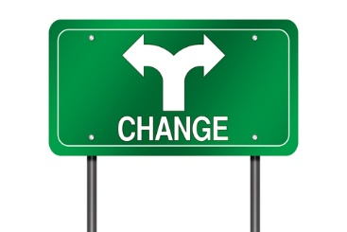
Introduction
After trialling or testing the product or service, feedback needs to be analysed and changes made if deemed necessary. It is better to alter or fix issues at the trial stage rather than when the product or service has been introduced to the market as a whole. It may be difficult to accept some of the feedback as a lot of time, effort and money may have been spent during the development phase, but it is critical to the success of the product or service to stay objective and respond to suggestions and issues as required.

Revising products and services
The great thing about market testing is that it allows for feedback to be generated and changes to be made based upon real and solid information. Feedback may come from customers, staff, suppliers or other stakeholders who may be affected by the service or product delivery. Revisions may be necessary due to:
- Operational issues such as staff levels, staff skills and training needs, required equipment
- Customer likes, dislikes, perceptions and feedback
- Staff feedback concerning product or service delivery issues
- Supply issues
- Cost issues
- Timing issues
- Product look or design
- Product or service delivery processes.



2.3 Monitor the introduction and implementation of the initiative

Introduction
As has been seen in previous units, it is important to gather feedback about the product or service that has been implemented. Monitoring the performance of a new product or service is not a one-time activity; it needs to be an ongoing process in order to respond to changes or customer information. Monitoring and analysing a product or service initiative can take many forms and it is important to get information and feedback from a variety of sources.

Monitoring product and service performance

Feedback regarding the introduction of a new product or service can come from many sources but it is important that a system has been developed to collect feedback. Information about a product or service performance could be first gathered through personal observation. Observing the product or service delivery in action enables issues and challenges to be seen and solutions developed. Feedback from staff and customers can be sought through interviews, focus groups, feedback questionnaires and meetings.
Feedback needs to be collected over a period of time to be able to make an informed decision about the success or failure of a new product or service. Analysing internal data that has been collected can provide evidence of the effectiveness of a new product or service and the data could be collected from numerous areas. Financial data could be analysed to look at costs, revenue and profit from new product or service introduction. Bookings, enquiries, visitor numbers could be analysed to determine if the new product or service is performing successfully.
After analysing the relevant data, a decision may need to be made regarding whether to continue with the product or service, or if changes need to be made. Changes could be related to cost increases due to external factors that were not anticipated or skills gaps with staff. This information could come from staff or customer surveys and feedback forms.
Below is an example of a customer feedback survey relating to a product.
Activity
Think about a product or service you use regularly, and complete the survey by circling the appropriate response. Discuss any ideas with your group.

Dear Customer:
Thank you for giving us the opportunity to better serve you. Please help us by taking a few minutes to tell us about the service that you have received so far. We appreciate your business and want to make sure we meet your expectations. Attached, you will find a coupon good for …… We hope that you will accept this as a token of our good will.
Sincerely, [MANAGER_NAME] Manager
How often do you typically use the product?
 | Once a year
 | Daily
 | Weekly
 | Once a month
 | Every 2-3 months
 | 2 – 3 times a year less often
 | Do not use
How did your [PRODUCT] perform?
 |  | Miserably |  | Somewhat Satisfactory | Very Satisfactory |  | Delightfully
Overall quality
Value
Purchase experience
Installation or first use experience
Usage experience
After purchase service (warranty, repair, customer service etc.)
How important was performance on these attributes?
 |  | Not Important | Somewhat Important |  | Important | Very Important
Overall quality
Overall quality
Value
Purchase experience
Installation or first use experience
Usage experience
Overall, how satisfied were you with your new [PRODUCT]?
 | Not at all satisfied
 | Somewhat Satisfied
 | Satisfied
 | Once a month
 | Very Satisfied
 | Delighted
Have you ever contacted customer service?
 | Yes
 | No

If you contacted [COMPANY] customer service, have all problems been resolved to your complete satisfaction?
Yes, by the company or its representatives
Yes, by me or someone outside the company
No, the problem was not resolved
Based on your awareness of [PRODUCT/SERVICE],is it better, the same, or worse than other brands of [ENTER CATEGORY}?
Much Better
Better
About the same
Worse
Much Worse
Please share with us a few things [Product/Service] could do better.

Based on your experience with [PRODUCT], how likely are you to buy [PRODUCT] again?
Definitely will
Probably will
Might or might not
Probably will not
Definitely will not
Based on your experience with [PRODUCT], would you recommend this product to a friend?
Definitely will
Probably will
Might or might not
Probably will not
Definitely will not
If you would like to share any additional comments or experiences about [PRODUCT], please enter them below.

2.4 Apply change management skills to facilitate the introduction and establishment of the initiative

Introduction
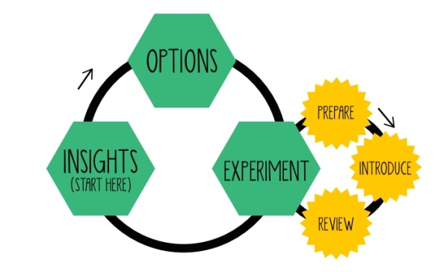
People often get used to routines and changing work duties or processes can often be challenging in an organisation. Introducing a new product or service may require new processes, equipment, skills, more staff, different working hours and increased effort. It is important to understand that introducing a new product or service may cause some challenges for staff and customers and that clear and effective communication is needed to ensure a smooth implementation process.

Implementing change
Change in the workplace is often a difficult situation but there are many things that can be done to make implementing change a success. The most important part of introducing change is effective communication. Staff, customers, stakeholders, suppliers all need to know why the change or new product is being introduced and what benefits the new product or service will bring. It is important that all staff members and stakeholders understand what the objectives of the new product or service are and what benchmarks or KPI’s are outlined to check the success or failure of the initiative. Staff may also need the opportunity to ask questions and clarify issues.
Introducing a new product or service may require management and supervisors to:
- Alter Standard Operating Procedures and explain these changes to staff

- Train staff and provide opportunities to practice delivering the new product or service
- Support staff during the introductory stage of the initiative by informing staff about what support is available and how to access it
- Change staff resource structures and teams
- Communicate progress and highlights/issues to staff and stakeholders
- Help staff overcome resistance to change.

Kotter's eight step change model
American John P Kotter is a Harvard Business School professor and leading thinker and author on organizational change management. Kotter's highly regarded books 'Leading Change' (1995) and the follow-up 'The Heart of Change' (2002) describe a helpful model for understanding and managing change. Each stage acknowledges a key principle identified by Kotter relating to people's response and approach to change, in which people see, feel and then change.
He suggests that 8 steps can be utilised to successfully implement change including:
- Increase urgency - inspire people to move, make objectives real and relevant
- Build the guiding team - get the right people in place with the right emotional commitment, and the right mix of skills and levels
- Get the vision right - get the team to establish a simple vision and strategy, focus on emotional and creative aspects necessary to drive service and efficiency

- Communicate for buy-in - Involve as many people as possible, communicate the essentials, simply, and to appeal and respond to people's needs. De-clutter communications - make technology work for you rather than against
- Empower action - Remove obstacles, enable constructive feedback and lots of support from leaders - reward and recognise progress and achievements
- Create short-term wins - Set aims that are easy to achieve - in bite-size chunks. Manageable numbers of initiatives. Finish current stages before starting new ones
- Don't let up - Foster and encourage determination and persistence - ongoing change - encourage ongoing progress reporting - highlight achieved and future milestones
- Make change stick - Reinforce the value of successful change via recruitment, promotion, new change leaders. Weave change into culture.
Kotter's eight step model is explained more fully on his website www.kotterinternational.com.

2.5 Promote the initiative to customers


Introduction
Developing a new product or service does not necessarily mean that it will be a success. If customers don’t know about the product then they will not be able to purchase it. Product or new service promotion strategies and activities are crucial to ensuring customers know about the product and how they can buy it. Promotional activities can take many forms and can range from verbal notification to advertising campaigns.

Promotional Mix
In previous units we identified the Marketing Mix which includes the four P’s: Price, Product, Promotion and Place. The promotional mix includes advertising, personal selling, sales promotion and public relations and any or all of the promotional mix elements may be used to promote a product or service.

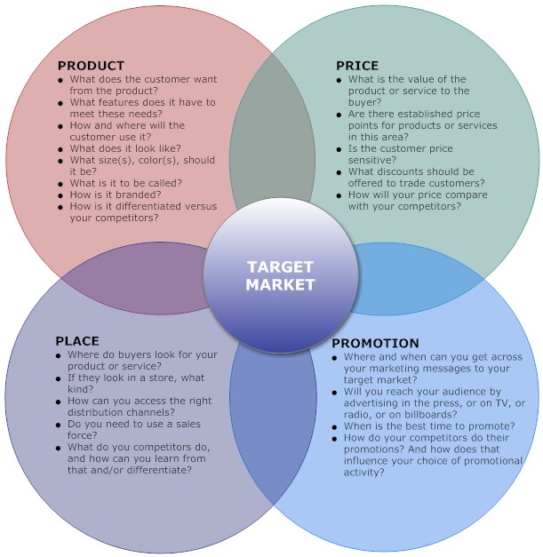
As can be seen in the matrix above, new product or service promotion requires some questions to be answered in order to make sure that promotional activities are targeted and effective. It is important to ask:
- How can the product or service be promoted? Where and when can you inform customers of the new product or service?
- What advertising media will be used? Will it just be internally generated through brochures, verbal notification to customers, email, website, banners, social media or events?
- When is the best time to promote to your customers?
- How do your competitors promote their products and services, and are they effective strategies?
- What types of promotional activities have already proved successful within your organisation?
- What budget is available for promotional activities?
Promotion strategies and activities are an important part of the sales process and there are many options available for promoting products and services. Some ideas could be:
- Hold a product launch event
- Create brochures, flyers and posters and distribute
- Website news, emails to customers, social media news release
- Discounts for early buyers
- Free trials
- Newspapers, web banners, TV, press releases
- Attend trade/industry shows and distribute information
- Utilise customer testimonials.
Activity
Think of a product or service at your organisation and identify all the ways that it is promoted to customers. Are there any ways to improve the promotional activities? Discuss with your group.

Work Projects
It is a requirement of this Unit you complete Work Projects as advised by your Trainer. You must submit documentation, suitable evidence or other relevant proof of completion of the project to your Trainer by the agreed date.
2.1 Outline a product or service plan that has been used within your organisation to introduce a new product. Explain to your trainer how the product or service was trialled or tested.
2.2. Describe to your trainer changes that were made to a product or service within your organisation after it was introduced. Explain:
- What the product or service was
- How it was introduced
- What changes were made to it and why.
2.3. Explain to your trainer the various mechanisms that are used within your organisation to monitor the performance of products and services:
- Bring some examples to class and show to your trainer.
2.4. Explain the process within your organisation when changes to delivery standards or SOPs are implemented:
- How are the changes implemented?
- Is it an effective process? Why?
2.5 Bring in three examples of promotional materials from your organisation.
- What other promotional methods are used?

Summary

Implement strategic product initiatives
After developing the product or service it is necessary to implement the initiative. It is not effective to rush and introduce a new initiative without testing the product or service first. It is important to trial the new product and to gather feedback from relevant people in order to see if there are any changes that need to be made. Gathering feedback from many different stakeholders is an effective way to gauge how well the initiative is doing and to find areas that may need to be modified. When changing a product or service, it is important to inform or the relevant people and to communicate the changes clearly. Once everyone has been told about any changes then the next step is to promote the new product or service to customers.

Element 3:
Evaluate strategic product initiatives

3.1 Record statistical data to enable evaluation against Key Performance Indicators to occur

Introduction

With advances in technology happening constantly it has become easier to record data electronically and to analyse it. Accounting software can easily track financial information, electronic customer feedback surveys are quick and gather data in a format that is easily accessed, and website traffic information is readily accessible as well. It is important that data about product performance is collected, analysed and checked against KPIs to measure the success or failure of product or service initiatives.

Data and information records
There is a lot of information that could be useful in evaluating the performance of a new product or service and being able to access this data easily is important. Different departments may collect different data but it may all be useful in evaluating a product’s performance. Data and statistics that may be applicable for analysing product or service performance could include:
- Cost information: product costs, delivery costs, staff costs, facility and equipment costs, training costs, maintenance and repair costs, supplier costs
- Revenue data including total revenue and profit/loss statements
- Visitor or user numbers
- Booking and reservation numbers
- Number of enquiries received
- Number of responses generated
- Customer feedback survey response numbers and responses.

Analysing data and statistics
One of the key stages in the product development cycle is the objectives phase. At this point the organisation determines what the new product or service is supposed to achieve. Targets could be set for many different reasons including financial achievements, customer satisfaction results and cost reduction. It is important to create data capture systems that can allow the organisation to examine the achievements of the product or service introduction and to determine if the targets are being met. The data collection mechanisms must be aligned to the key performance indicators in order to allow a realistic examination of the success or failure of the service or product.

3.2 Solicit and record feedback from stakeholders


Introduction
After introducing a new product or service it is crucial to gather feedback to determine how the initiative is performing. Feedback should come from a variety of sources and should be analysed objectively in order to identify areas of strength and opportunities for improvement. Hospitality and tourism organisations need to be customer facing in terms of feedback activities which includes proactive information collecting systems.

Stakeholder feedback
There are many stakeholders whose feedback may be relevant and useful in analysing the performance of new product or service initiatives. The staff involved or connected to the initiative need to be provided with opportunities to give feedback about concerns, issues or successes of the product or service activity. Feedback from staff could be gathered from staff feedback surveys, meetings, interviews and observation.
Obviously the customers who purchase the product or service need to be provided with opportunities to comment on the initiative. Customer evaluation or feedback surveys are an effective way to gather information but they must be easily accessible, comprehensive and responses easily analysed. Customer feedback may change over time so it is important to gather feedback regularly.
Suppliers, partners, consultants and external stakeholders also need to be able to offer feedback relating to product and service initiatives as well. Although they may not seem to be directly connected to the activity, their feedback may help to identify issues or areas for improvement.



3.3 Compare projected outcomes against actual outcomes


Introduction
As a part of the product or service development plan, targets or KPI’s would have been projected in order to identify parameters to gauge the performance of the new product or service. It is important to examine the projected outcomes against the actual results of the initiative. In some instances the actual results may be much better than predicted or they may not have reached the desired levels anticipated.

Comparing performance results
Once a product or service has been introduced and feedback gathered, the information needs to analysed against the projected objectives. KPI’s that have been identified could relate to increases in bookings as a number or percentage, they could be financial statements about revenue, profit or costs, or they could involve customer satisfaction targets such as Net Promoter Scores (NPS).
Net Promoter Score is a common KPI used in many organisations. It involves one question and a rating scale. The question that is asked is:
‘How likely is it that you would recommend [your company/service/product] to a friend or colleague?’
Respondents are organised into three categories: promoters, passives and detractors. The rating is out of 10 and promoters rate at (9-10), passives at (7-8) and detractors (0-6).
To calculate your company’s NPS, take the percentage of customers who are Promoters and subtract the percentage who are Detractors.
Example: If you received 100 responses to your survey:
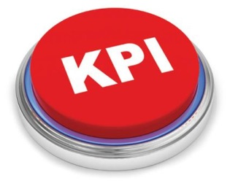
10 responses were in the 0–6 range (Detractors)
20 responses were in the 7–8 range (Passives)
70 responses were in the 9–10 range (Promoters)
Calculating the percentages for each group gives you 10%, 20%, and 70% respectively.
Subtract 10% (Detractors) from 70% (Promoters), which equals 60%. Since a Net Promoter Score is always shown as just an integer and not a percentage, your NPS is simply 60.
The higher the score, the more satisfied your customers are. The NPS may have been set as a KPI and the projected score should be checked against the actual rating after product or service implementation. This is just one example of a KPI that may have been identified for performance analysis and the results of the comparisons offer insights into unintended positive or negative results.

3.4 Determine and implement changes, if any, that need to be made to maintain or revise the initiative

Introduction
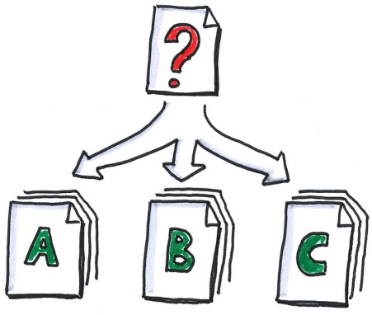
Analysis of projected KPIs versus actual targets enables a clear picture to be developed of the overall performance of a new product or service initiative. If all of the processes in the product development have been followed correctly, if marketing activities have been conducted, and staff have implemented the initiative effectively, then the results may be achieved as per projections. It is possible that the initiative achieves better results than expected and it is also possible for the product or service to have under-performed. It is important to analyse the results and data in order to identify areas of strength and areas that may need to be altered to improve the initiative performance.

Identifying areas for change
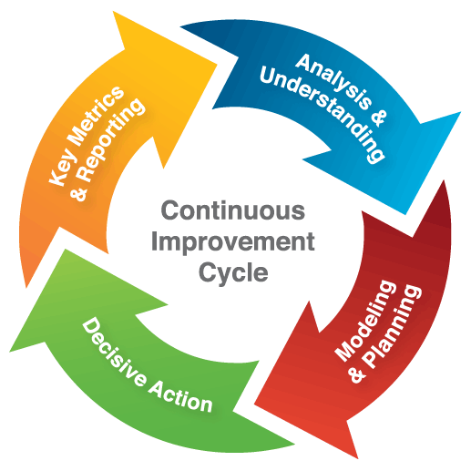
It is important to check the performance of a product or service initiative. Evaluating the product success or failures enables identification of areas to improve in order to achieve desired outcomes. Some product and service initiatives may perform well beyond the expectations of the product plan but it still important to determine why the performance is so good in order to identify areas of strength within the organisation or team. This analysis may provide information that could help improve other product or service delivery within the organisation. Once failure or success areas have been determined, it is necessary to respond to the information and implement any changes that may be required.
More training may be identified as a necessary change, new equipment or technology may be required, or more staff resources may need to be allocated to respond to issues in product or service delivery. Once areas for improvement are determined, any changes deemed necessary need to follow change management principles which have been discussed in previous units. It is important to continue to assess the performance of new initiatives as implemented changes may cause a knock-on effect where other areas or processes may be impacted by changes. The main point to realise is that the product implementation process is cyclical and should under-go review and change as required.

Work Projects
It is a requirement of this Unit you complete Work Projects as advised by your Trainer. You must submit documentation, suitable evidence or other relevant proof of completion of the project to your Trainer by the agreed date.
3.1 Bring two examples of statistics that your organisation gathers and show your trainer.
3.2. Bring an example of customer feedback and show your trainer:
- Customer evaluation form
- Online review
- Staff feedback forms
- Customer complaint/compliments.
3.3. Provide an example of a marketing strategy that outlines projected outcomes from a product or service and evidence of actual results.
3.4. Provide an example of a change that has been implemented due to feedback from customers within your organisation.

Summary

Evaluate strategic product initiatives
Responding to feedback is an important stage in the product introduction process. It is critical for an organisation to gather feedback and statistics about a product or service in order to be able to respond and alter the initiative if necessary. All relevant stakeholders need to be provided with opportunities to respond to a new product or service initiatives and feedback should be collected in a variety of ways. Keeping statistics relating to product development allows an organisation to clearly understand the positive benefits or issues that relate to it.

Presentation of written work

Introduction
It is important for students to present carefully prepared written work. Written presentation in industry must be professional in appearance and accurate in content. If students develop good writing skills whilst studying, they are able to easily transfer those skills to the workplace.

Style

Students should write in a style that is simple and concise. Short sentences and paragraphs are easier to read and understand. It helps to write a plan and at least one draft of the written work so that the final product will be well organised. The points presented will then follow a logical sequence and be relevant. Students should frequently refer to the question asked, to keep ‘on track’. Teachers recognise and are critical of work that does not answer the question, or is ‘padded’ with irrelevant material. In summary, remember to:
- Plan ahead
- Be clear and concise
- Answer the question
- Proofread the final draft.

Presenting Written Work
Types of written work
Students may be asked to write:
- Short and long reports
- Essays
- Records of interviews
- Questionnaires
- Business letters
- Resumes.
Format
All written work should be presented on A4 paper, single-sided with a left-hand margin. If work is word-processed, one-and-a-half or double spacing should be used. Handwritten work must be legible and should also be well spaced to allow for ease of reading. New paragraphs should not be indented but should be separated by a space. Pages must be numbered. If headings are also to be numbered, students should use a logical and sequential system of numbering.
Cover Sheet
All written work should be submitted with a cover sheet stapled to the front that contains:
- The student’s name and student number
- The name of the class/unit
- The due date of the work
- The title of the work
- The teacher’s name
- A signed declaration that the work does not involve plagiarism.
Keeping a Copy
Students must keep a copy of the written work in case it is lost. This rarely happens but it can be disastrous if a copy has not been kept.
Inclusive language
This means language that includes every section of the population. For instance, if a student were to write ‘A nurse is responsible for the patients in her care at all times’ it would be implying that all nurses are female and would be excluding male nurses.
Examples of appropriate language are shown on the right:
Mankind | Humankind
Barman/maid | Bar attendant
Host/hostess | Host
Waiter/waitress | Waiter or waiting staff

Recommended reading
Bowie. D., Buttle. F., (2013); Hospitality Marketing: Pronciples and Practice; (Second Edition), Routledge
Komppula. R.; 10th Nordic Tourism Research Symposium; October 18-20 2001, Vasa, Finland
Kotler.P., Bowen. J.T., Makens. J., (2013); Marketing for Hospitality and Tourism (6th Edition); Pearson
Middleton; V.T.C. 1989. Tourist Product. In: Witt, S.F. & Moutinho, L. (eds.). Tourism Marketing and Management Handbook; Hempel Hempstead:Prentice-Hall
Middleton; V.T.C. & Clarke, J. 2001. Marketing in Travel and Tourism; 3rd Edition. Oxford: Butterworth-Heinemann
Morgan; M. 1996. Marketing for Leisure and Tourism; Hemel Hempstead: Prentice Hall Europe
Murphy, P., Pritchard, M.P. & Smith, B. 2000; The Destination product and its impact on traveller perceptions; Tourism Management 21 (2000). pp. 43 – 52
Pearce, D. 1989; Tourist Development; Second Edition. London: Longman Scientific and Technical
Seaton, A.V. 1996. The marketing mix: the tourism product. In: Seaton, A.V. & Bennet, M.M; Marketing Tourism Products. Concepts, Issues, Cases; Falmouth: International Thomson Business Press
Shostack, G.L. 1984; Service Design in the Operating Environment; In: George, W.R. & Marshall, C. (eds.) Developing New Services. Chicago: American Marketing Association. pp. 27 – 43
Smith, S.L.J. 1994; The Tourism Product. Annals of Tourism Research Vol. 21; 3. pp. 582-595
Zeithaml, V.A. & Bitner, M.J. 1996; Services Marketing. Integrating Customer Focus Across the Firm. 2ndEdition; US:McCraw-Hill Higher Education
Zeithaml, V.A., Parasuranam, A. & Berry, L.L. 1990; Delivering Quality Service. Balancing Customer Perceptions and Expectations; New York: The Free Press

Trainee evaluation sheet

Create, implement and evaluate strategic product initiatives
The following statements are about the competency you have just completed.
Please tick the appropriate box | Agree | Don’t Know | Do Not Agree | Does Not Apply
There was too much in this competency to cover without rushing.
Most of the competency seemed relevant to me.
The competency was at the right level for me.
I got enough help from my trainer.
The amount of activities was sufficient.
The competency allowed me to use my own initiative.
My training was well-organised.
My trainer had time to answer my questions.
I understood how I was going to be assessed.
I was given enough time to practice.
My trainer feedback was useful.
Enough equipment was available and it worked well.
The activities were too hard for me.

The best things about this unit were:

The worst things about this unit were:

The things you should change in this unit are:

Trainee self-assessment checklist
As an indicator to your Trainer/Assessor of your readiness for assessment in this unit please complete the following and hand to your Trainer/Assessor.

Create, implement and evaluate strategic product initiatives
 |  | Yes | No*
Element 1: Create strategic product initiatives
1.1 | Identify the context for product development
1.2 | Undertake market research on identified opportunities and identified target markets
1.3 | Determine product life cycle issues that apply to identified opportunities and products
1.4 | Determine financial issues that relate to the development of product initiatives
1.5 | Research product development opportunities that align with the context that applies
1.6 | Develop product development plans reflecting research information and business objectives
1.7 | Produce the identified product or service initiative
Element 2: Implement strategic product initiatives
2.1 | Trial the initiative in accordance with established plans
2.2 | Revise the initiative as required on the basis of operational matters and customer feedback
2.3 | Monitor the introduction and implementation of the initiative
2.4 | Apply change management skills to facilitate the introduction and establishment of the initiative
2.5 | Promote the initiative to customers
Element 3: Evaluate strategic product initiatives
3.1 | Record statistical data to enable evaluation against Key Performance Indicators to occur
3.2 | Solicit and record feedback from stakeholders
3.3 | Compare projected outcomes against actual outcomes
3.4 | Determine and implement changes, if any, that need to be made to maintain or revise the initiative

Statement by Trainee:
I believe I am ready to be assessed on the following as indicated above:
Signed: _____________________________ | Date: ____________

Note:
For all boxes where a No* is ticked, please provide details of the extra steps or work you need to do to become ready for assessment.





